**Project Report**

On

**AUTOMATED FACE DETECTION AND RECOGNITION WEB BASED MONITORING SYSTEM**

Submitted in fulfillment of the requirements of University of Mumbai for the degree of **Bachelor of Engineering**

By

### SALUNKHE VRUSHALI VASASNT (118CP1236B)

### PATIL SUMEET GAJENDRA (118CP1311A)

### PATIL SHUBHAM SUDHIR (118CP1213A)

Under Supervision of:

**Prof. Anil Kale**



## Department of Computer Engineering

**Mahatma Gandhi Mission’s College of Engineering & Technology Kamothe, Navi Mumbai – 410 209**

**University of Mumbai**

**Academic year: 2021-2022**

# **Certificate**

This is to certify that the Project work **“AUTOMATED FACE DETECTION AND RECOGNITION WEB BASED MONITORING SYSTEM”** done by **"** **VRUSHALI SALUNKHE (118CP1236B) , SUMEET PATIL(118CP1311A), SHUBHAM PATIL (118CP1213A)"** students of **“Department of Computer Engineering”** is a record of bonafide work carried out of them. This Project is done as fulfillment of obtaining “**Bachelor of Computer Engineering”** degree to be awarded by **“Mahatma Gandhi Mission of College of Engineering and Technology, Kamothe, Navi Mumbai”.**

( Prof. Anil Kale ) ( Prof. vidyaBharde)

Project Guide Project Co- ordinator

( Dr. Ashok Kanthe) (Dr. Geeta Lathkar)

Head of Department Director MGMCET

# **Project Report Approval For B.E.**

This project report entitled **“AUTOMATED FACE DETECTION AND RECOGNITION WEB BASED MONITORING SYSTEM"** done by “**VRUSHALI SALUNKHE (118CP1236B), SUMEET PATIL (118CP1311A), SHUBHAM PATIL (118CP1213A)"** is approved for the degree of **“Bachelor of Computer Engineering”.**

#### **Examiners :**

**1.**

**2.**

Date : _

Place : MGMCET,

Kamothe, Navi Mumbai.

**Declaration**

I declare that this written submission represents my ideas in my own words and where others' ideas or words have been included, I have adequately cited and referenced the original sources. I also declare that I have adhered to all principles of academic honesty and integrity and have not misrepresented or fabricated or falsified any idea/data/fact/source in my submission. I understand that any violation of the above will be cause for disciplinary action by the Institute and can also evoke penal action from the sources which have thus not been properly cited or from whom proper permission has not been taken when needed.

### SALUNKHE VRUSHALI VASASNT (118CP1236B)

PATIL SUMEET GAJENDRA

(118CP1311A)

### PATIL SHUBHAM SUDHIR

### (118CP1213A)

Date :

Place : MGMCET, Kamothe, Navi Mumbai .

**ABSTRACT**

The **conventional** **technique** of attendance marking is a tedious **assignment** **in lots of** schools, colleges, **studying** rooms and libraries. It may be **very** time-consuming. While the flow toward digital technology is being multiplied each hour biometrics technology has all started to have an effect on human beings greater and greater. Biometrics verifies the identification via traits which includes fingerprints, faces, palm prints, voice, hand-written signatures, and so on. Face recognition has set an essential biometric feature, which can be effortlessly procurable and can access statistics with no want of unique cooperation from the software. This project involves building face detection and facial recognition for getting statistics of the users, marking their presence through detecting faces, time in of the user, and time out of the users(students, teachers, employees, etc.) at the premises. It is covering features such as face detection, alignment, training the data, recognition, creating reports of data, along with the development of a web application to cater to various use cases of the system such as registration of the latest students, addition of photographs to the training dataset, and viewing attendance reports, etc. This project intends to feature as an efficient alternative for conventional manual attendance structures by changing it with our system. It may be applied in schools, colleges, offices, companies wherein safety is important.

**Table of Contents**

|  |  |  |
| --- | --- | --- |
|  | **Abstract** | **v** |
|  | **Table of Contents** | **vi** |
|  | **List of Figures** | **vii** |
| **Chapter 1** | **Introduction** | **1** |
|  | 1.1 Motivation | 2 |
|  | 1.2 Problem Statement | 2 |
|  | 1.3 Objectives | 2 |
|  | 1.4 Scope | 3 |
| **Chapter 2** | **Review of Literature (Existing Systems)** | **4** |
|  | 2.1Student Attendance System using Face Recognition | 4 |
|  | 2.2 Face Detection and Recognition System using Digital Image Processing | 5 |
|  | 2.3 Face Recognition from Video using Deep Learning | 5 |
|  | 2.4 Face Recognition Attendance System Based on Real-Time Video Processing | 6 |
| **Chapter 3** | **Requirement Analysis** | **7** |
|  | 3.1 Functional Requirements | 7 |
|  | 3.2 Non-functional Requirements | 8 |
|  | 3.3 Hardware Requirements | 10 |
|  | 3.4 Software Requirements | 10 |
| **Chapter 4** | **Design** | **11** |
|  | 4.1 Class Diagram | 12 |
|  | 4.2 State Diagrams | 13 |
|  | 4.3 Use-Case Diagram | 14 |
|  | 4.4 Sequence Diagram | 15 |
|  | 4.5 E-R Diagram | 21 |
|  | 4.6 Component Diagram | 22 |
|  | 4.7 Package Diagram | 23 |
|  | 4.8 Deployment Diagram | 24 |
| **Chapter5** | **Report on the Present Investigation** | **26** |
|  | 5.1 Methodology | 26 |
|  | 5.2 Implementation | 28 |
| **Chapter 6** | **Result & Outputs** | **30** |
| **Chapter 7** | **Conclusion** | **41** |
|  | **References** | **43** |
|  | **Appendix** | **44** |

**List of Figures**

|  |  |  |
| --- | --- | --- |
| **Figure No.** | **Figure Name** | **Page No.** |
| 2.1 | Operating process of attendance system | 4 |
| 2.2 | Geometric approach of face Recognition | 5 |
| 2.3 | Data Flow Diagram of face Recognition using Deep Learning | 6 |
| 4.1 | Class Diagram | 12 |
| 4.2 | State Diagram | 13 |
| 4.3 | Use-Case Diagram | 14 |
| 4.4 | Sequence Diagram | 15 |
| 4.5 | Activity Diagram | 18 |
| 4.6 | E-R Diagram | 21 |
| 4.7 | Component Diagram | 22 |
| 4.8 | Package Diagram | 23 |
| 4.9 | Deployment Diagram | 24 |
| 6.1 | Main Dashboard (Time-in , Time-out and Login) | 30 |
| 6.2 | Marking attendance in the system | 30 |
| 6.3 | Marking attendance out the system | 31 |
| 6.4 | Result of above attendance | 31 |
| 6.5 | User Login (Admin & Students): | 32 |
| 6.6 | Admin Dashboard | 32 |
| 6.7 | Admin Features | 33 |
| 6.7.1 | Student Registration (Using Username & Password) | 33 |
| 6.7.2 | Successful Registration | 33 |
| 6.7.3 | Adding images for student using username | 34 |
| 6.7.4 | Capturing images using web cam | 34 |
| 6.7.5 | Successful creation of dataset for training | 35 |
| 6.7.6 | Initialization of training dataset | 35 |
| 6.7.7 | Completion of Training dataset | 36 |
| 6.7.8 | Classification graph of trained dataset | 36 |
| 6.8 | Attendance Report | 37 |
| 6.9 | Searching of Records using username and from – to date | 37 |
| 6.10 | Searching of record using particular date | 38 |
| 6.11 | Student Dashboard | 39 |
| 6.12 | Student Features (Viewing attendance Report) | 40 |

**Chapter 1**

**INTRODUCTION**

Automated face detection and recognition web-based monitoring system targets to automate the conventional guide attendance structures that is being redundant. It additionally permits schools, colleges, companies, malls, libraries, and many others to preserve their statistics like in time, out time, breaks time, and attendance of customers digitally. Digitalization of the machine might additionally assist in higher visualization of the information and information the usage of graphs to show the no. of the user (student) present today, the entire hours spent by each user (student), and their break time. The improved capabilities functions as an efficient and alternative over the conventional attendance structures.

We have 2 types of users of the system:

1. Student
2. Admin

Following functions can be performed by the admin:

* Login to the system.
* Register new students to the system.
* Add student photos to the training data set.
* Train the model.
* View attendance report of all students. Attendance can be filtered by date or student username.

Following functions can be performed by the student:

* Login.
* To Mark his/her time-in and time-out by scanning their face(For prototype purpose)
* View attendance report of self.

**1.1 Motivation**

Due to the upcoming era of artificial intelligence, machine learning and their application related to biometrics and their authentication are in great demand so we came up with an idea of creating a automated face detection and recognition web based monitoring system which can be applied in various areas such as school, college, offices, organization etc.

**1.2 Problem Statement**

The face recognition system includes face detection, face preprocessing and face recognition processes. Therefore, it is necessary to extract the facial features from the face detection process and separate the face from the background pattern, which provides the basis for the subsequent extraction of the face difference features. The recent rise of the face recognition technique based on the depth of learning detection and classification methods, compared to the traditional method not only shorten the time, and the accuracy is effectively improved and improvised. Face recognition of the separated faces is a process offeature extraction and contrast identification of the normalized face images in order to obtain the identity of human faces in the images and creating classification model.

**1.3 Objectives**

The objective of this document is to specify software requirements and performance of the Automated face detection and recognition web based monitoring system. It is intended to be an entire specification of what functionality our system provides. Furthermore, this project aims to automate the regular attendance system where the attendance is marked manually. It also enables organization, school, colleges etc. To take care of its records like time-in, time-out, break time and attendance digitally. Digitalization of the system would also help in better visualization of the data and statistics using graphs to display the no. of students present today, total hours spend of each student and their break time. Its added features function an efficient upgrade and replacement over the standard attendance system.

**1.4 Scope**

In today’s generation Face recognition has become one of the powerful tool in our society. It has made a lot of progress in the field of security. It is a very effective tool that can help to identify criminals and software companies are leveraging the technology to help users access the technology. This technology can be further updated to be used in other field such as ATMs, accessing confidential files, or other sensitive materials.This project gives out as basis for future projects based on face detection and recognition. This project also convers web development and database management with a handy and easy to understand UI. By Using this system any corporate offices, school and organization can update their traditional way of marking attendance of the students and can also generate their availability(presence) file throughout the month. The proposed system has been modified as per the requirements.

We have studied all the algorithms in the base paper and also appraised the algorithm which have some drawback for best result.We also considered all the software and hardware requirements of the project. Henceforth looking forward for the best implementation

**Chapter 2**

**Review of Literature**

A literature review summarise and explains the whole and current state of knowledge on a certain topic as found in academic books and journal articles. There are two types of literature reviews that students may be asked to write at university: one as a stand-alone assignment in a course, often as part of their training in research processes in their field, and the other as part of an introduction to or preparation for a longer work, usually a thesis or research report.

The topic and perspective of your review, as well as the type of hypothesis or thesis argument you make, will be determined by the type of review you're writing. One way to do so is to understand the differences.

**2.1.**

* **Title:** Student Attendance System using Face Recognition
* **Publication and year:** Proceedings of the International Conference on Smart Electronics and Communication (ICOSEC 2020) **IEEE**
* **Author Name:** Samridhi Dev, Tushar Patnaik
* **Technique used:** OpenCV, Haar classifiers, KNN, CNN, SVM, Generative adversarial
* **Advantages:**

1. KNN is used which gives accuracy, robustness and less time complexity.
2. GAN is used for its ability to retain texture information.

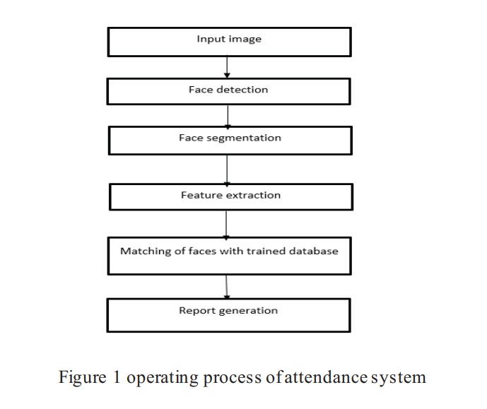

**2.2.**

* **Title:** Face Detection and Recognition System using Digital Image Processing
* **Publication and year:** Proceedings of the Second International Conference on Innovative Mechanisms for Industry Applications (ICIMIA 2020) IEEE Xplore
* **Author Name :** Gurlove Singh, Amit Kumar Goel, School of Computing Science and engineering, Galgatias University, Noida, India.
* **Technique used :** Eigenface method, principal component analysis (PCA), Gabor Feature Method
* **Advantages:**
* As PCA is used it
* Removes Correlated Features,
* Improves Algorithm Performance,
* Reduces Overfitting,
* Improves Visualization.
* DIFFERENT APPROACHES OF FACE RECOGNITION :

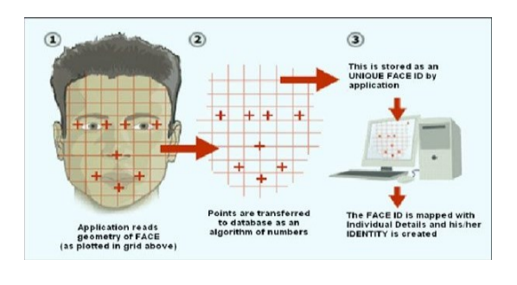

**2.3.**

* **Title :** Face Recognition Attendance System Based on Real-Time Video Processing
* **Publication and year :** SPECIAL SECTION ON GIGAPIXEL PANORAMIC VIDEO WITH VIRTUAL Reality published July 10, 2020, date of current version September 11, 2020 IEEE
* **Author Name:** HAO YANG AND XIAOFENG HAN ,China
* **Technique used:** Subspace analysis, Neural Network method , Support Vector Machine method
* **Advantages:**
* 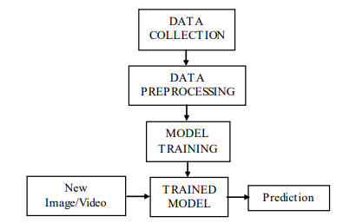System is based on real-time video processing

**2.4.**

* **Title :** Face Recognition from Video using Deep Learning
* **Publication and year:** Proceedings of the Fifth International Conference on Communication and Electronics Systems (ICCES 2020) IEEE Conference
* **Author Name:** Saibal Manna, Sushil Ghildiyal, Kishankumar
* **Technique used:** Convolutional neural network, security, FaceNet
* **Advantages:** 
  + - It work with any sort of pictures and is sensibly strong to changes in face appearance or orientation, light conditions , and different variables.

**Chapter 3**

**Requirement Analysis**

In systems engineering and software engineering, requirements analysis focuses on the task that determine the needs or conditions to meet the new or altered product or project, taking account of the possibly conflicting requirements of the various stakeholders, analyzing, documenting, validating and managing software or system requirements. Requirements analysis is critical to the success or failure of a systems or software project.

The requirements should be documented, actionable, measureable, testable, traceable, related to identified business needs or opportunities, and defined to a level of detail sufficient for system design.

The process of the requirement analysis is:

1. 1. Eliciting requirements: - It involves gathering requirements by communicating with the customers.
2. 2. Analyzing requirements: - It helps to determine the quality of the requirements.
3. 3. Requirements modeling: - It involves documentation of the various requirements.

In order to develop the specific system that will operate in the target environment and meet the specific objectives, requirement analysis was conducted. Through field visits at different channel offices, requirements for the website were obtained.

**3. 1 Functional Requirements**

**3.1.1 Manage Registration and Login**

**3.1.1.1 Register new student**

Description: Only Admin can register new student by giving them unique username

Input: Student username and password

Output: success message will displaying that user has been created.

**3.1.1.2 Log-In to the system**

Input: User login credentials

Output: If the credentials are correct, user will be redirected to the dashboard of our system

Exception Flow: If user’s entered credentials are incorrect then user will be redirected to the login page again displaying an error message.

**3.1.2 Manage Attendance Details**

**3.1.2.1 Mark your attendance-in**

Input: User will scan his/her face using the external web camera(Only for prototype purpose)

Output: system will identify the user uniquely displaying usernames and will mark his/her in-time to the database. The same success message will transmit to the user.

**3.1.2.2 Mark your attendance-out**

Input: User will scan his/her face using the external web camera(Only for prototype purpose)

Output: system will identify the user uniquely displaying usernames and will mark his/her out-time to the database. The same success message will transmit to the user.

**3.1.2.3 View my attendance report**

Description: Student may often need to see his / her attendance record on particular date or throughout the month or year. Using this feature one can see his / her attendance record as per requirement.

Input: User selection(date and username/ date)

Output: Statistical analytics(record table and graphs) of the particular student who is currently logged into the system will be displayed.

**3.1.3 Manage Student Details**

**3.1.3.1 Add photo of the student**

Description: Admin only can access this feature by logging in. Admin can add photos of an student during the registration process.

Input: Username of the student.

Output: Success message of record has been added will display.

Process: System will process an image and will generate necessary system data into a folder to identify each student uniquely.

**3.1.3.2 Train the system**

Input: user selection(clicking train)

Output: system will process all the available records of the students and will generate necessary system data to identify each student uniquely with graph of classification.

**3. 3 Hardware Requirements**

1. 1. Windows XP, Vista / Mac OS 9 or 10 or higher.
2. 2. Processor: 2 x 1.6 GHz CPU.
3. 3. RAM: 4 GB RAM.
4. 4. Minimum of 20 GB of available space on hard disk.
5. 5. Monitor Resolution 1024 X 768 or higher.
6. 6. Keyboard and a Microsoft Mouse or some other compatible pointing device.
7. 7. Camera(CCTV, monitor webcam, Mobile camera,etc)

**3. 4 Software Requirements**

## Technology/Platform/Tools used Technology:

* Django
* Python
* OpenCV
* Dlib
* Open-Source Face Recognition Library
* SQLITE Database.
* Bootstrap(HTML,CSS,JavaScript)

**Platform:**

* Windows

**Tools:**

* Visual Studio Code

**Chapter 4**

**Design**

Diagrams are very frequently used to explain reasoning processes. Many scientists have investigated why diagrams are successfully used to convey information and support reasoning. Scientists who are part of 'Diagram based reasoning' (DBR) has revealed the advantages of diagrams over linguistic representations, insisting that their findings will have immediate and far-reaching consequences for teaching practices.

The diagrams enhance visual understanding of a system and the general overview is clearly highlighted. There are various processes of a system both at the front-end and the back-end that needs to be properly specified for a person who has no idea about the mechanism of that system. The types of diagrams that are used in software engineering projects are:

1. 1. Entity-Relationship diagram
2. 2. Data Flow diagram
3. 3. UML diagrams (Use Case and Class Diagrams)
4. 4. Sequence diagram
5. 5. Activity diagram

These diagrams enable better visualization and understanding of the working and scope of a project. Designing of any prototype initiates with a ground level diagram or flowchart and later the entities are defined along with their attributes. The relationships between the entities are established further. The workflow is determined and the functions are distributed to all the entities. The classes are defined and the structure of the system is elaborated further.

**4.1 CLASS DIAGRAM**

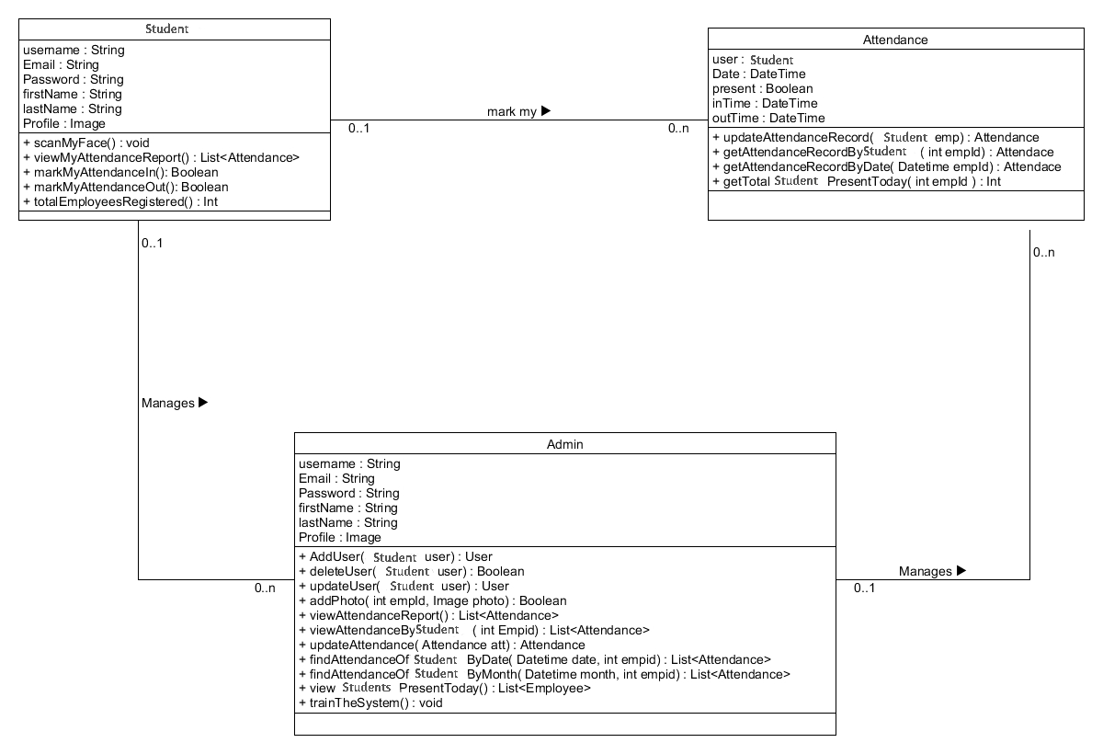

We have prepare class diagram to understand the blueprints of our system in better and simple way. A class diagram is used to model the objects that make up the system, to display the relationships between the objects and to describe what those objects do and the services that they provide.

**4.2 STATE DIAGRAM**

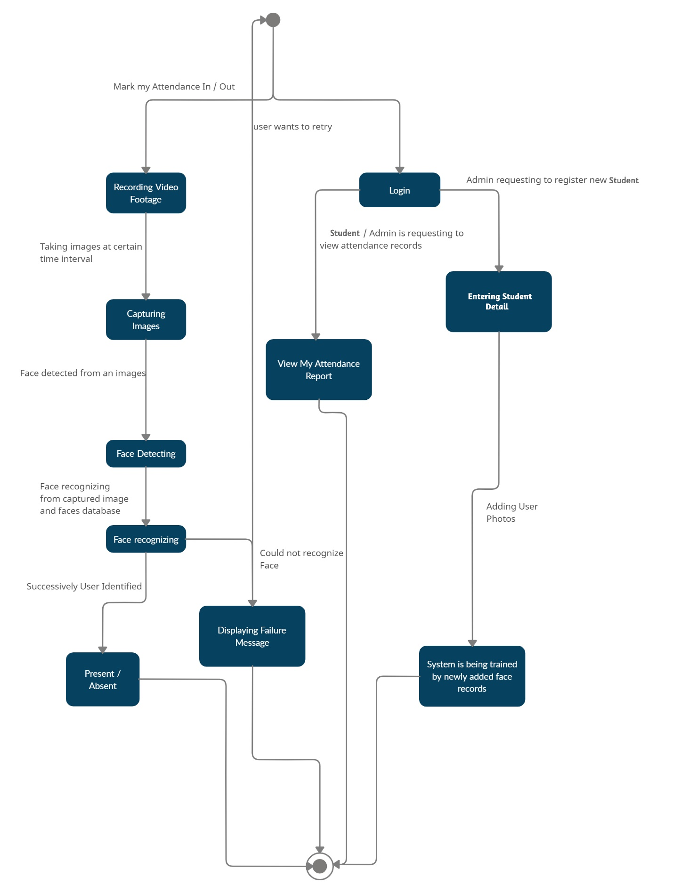

**4.3 USECASE DIAGRAM**

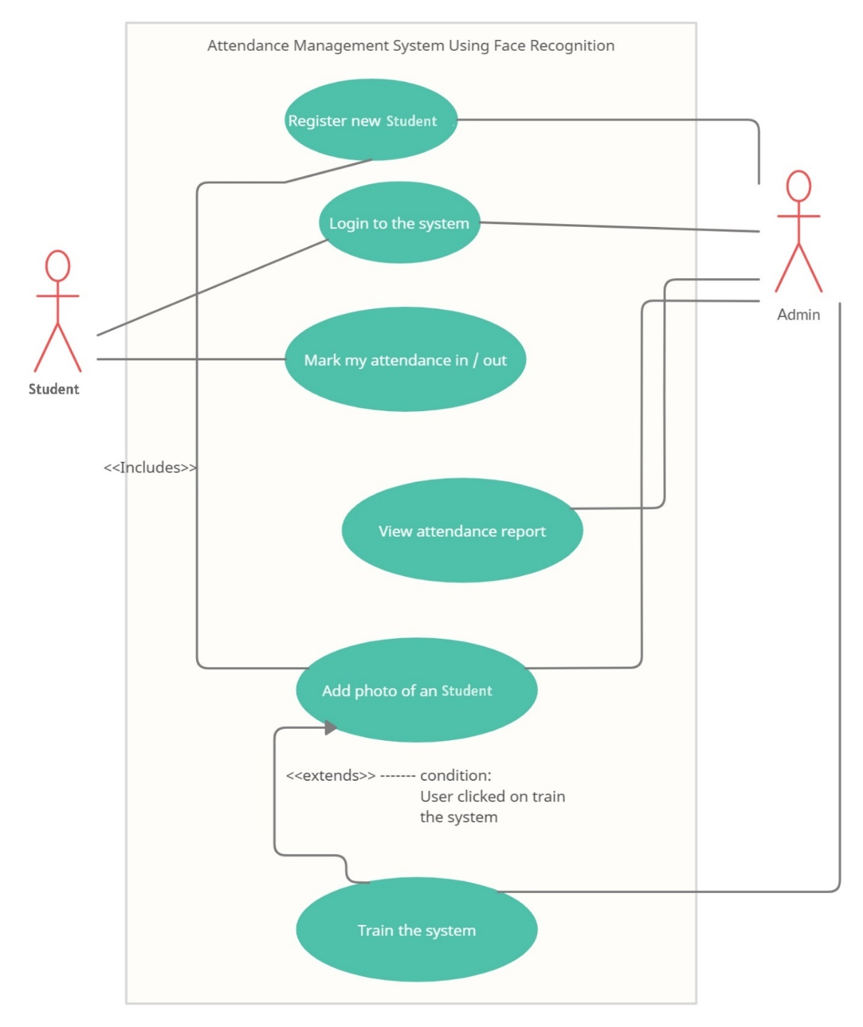

We have prepare UML diagram to understand the system in a better and simple way. A single diagram is not enough to cover all the aspect of the system. UML defines various kinds of diagram to cover most of the aspects of the system.

**4.4 SEQUENCE DIAGRAM**

**4.4.1 LOGIN PROCESS**

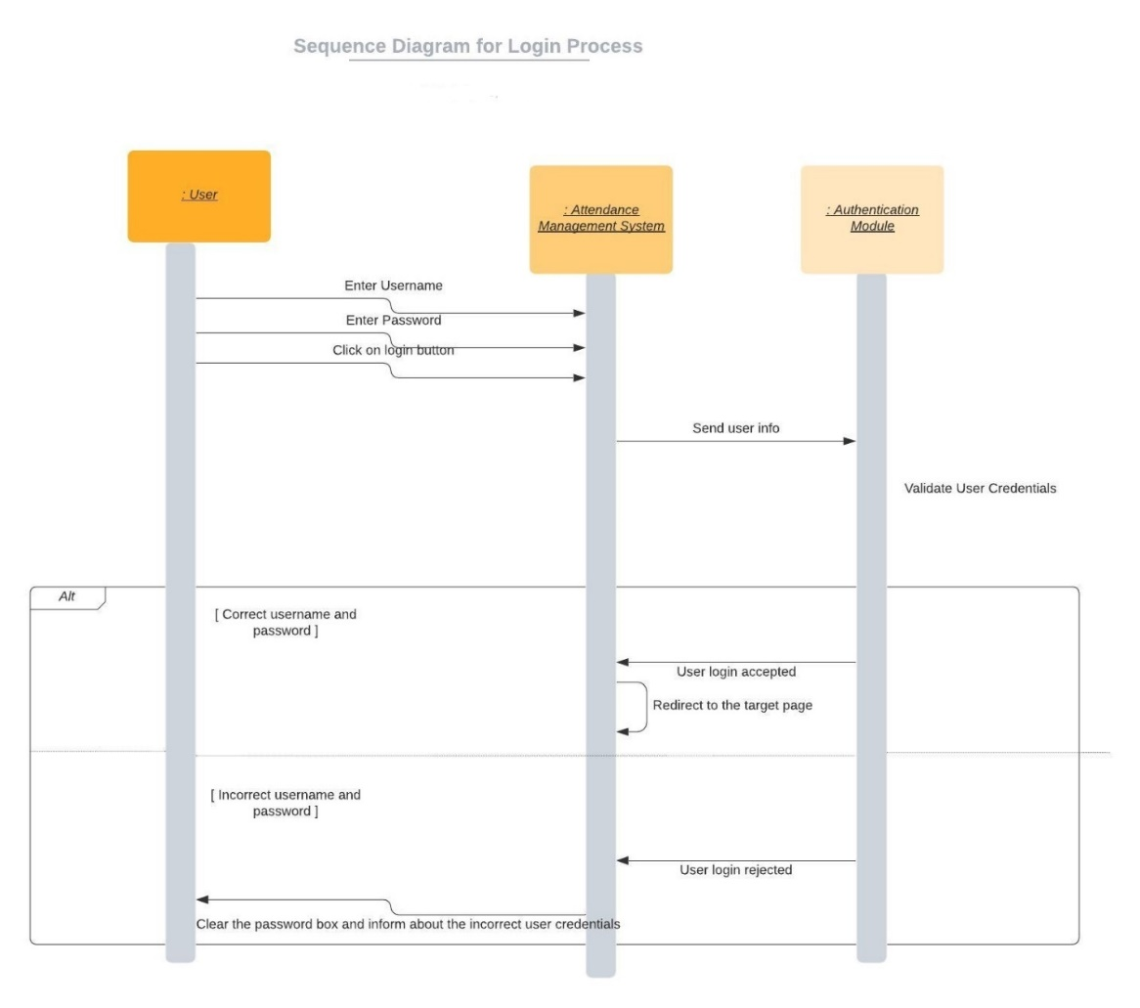

**4.4.2 ATTENDANCE / MONITORING**

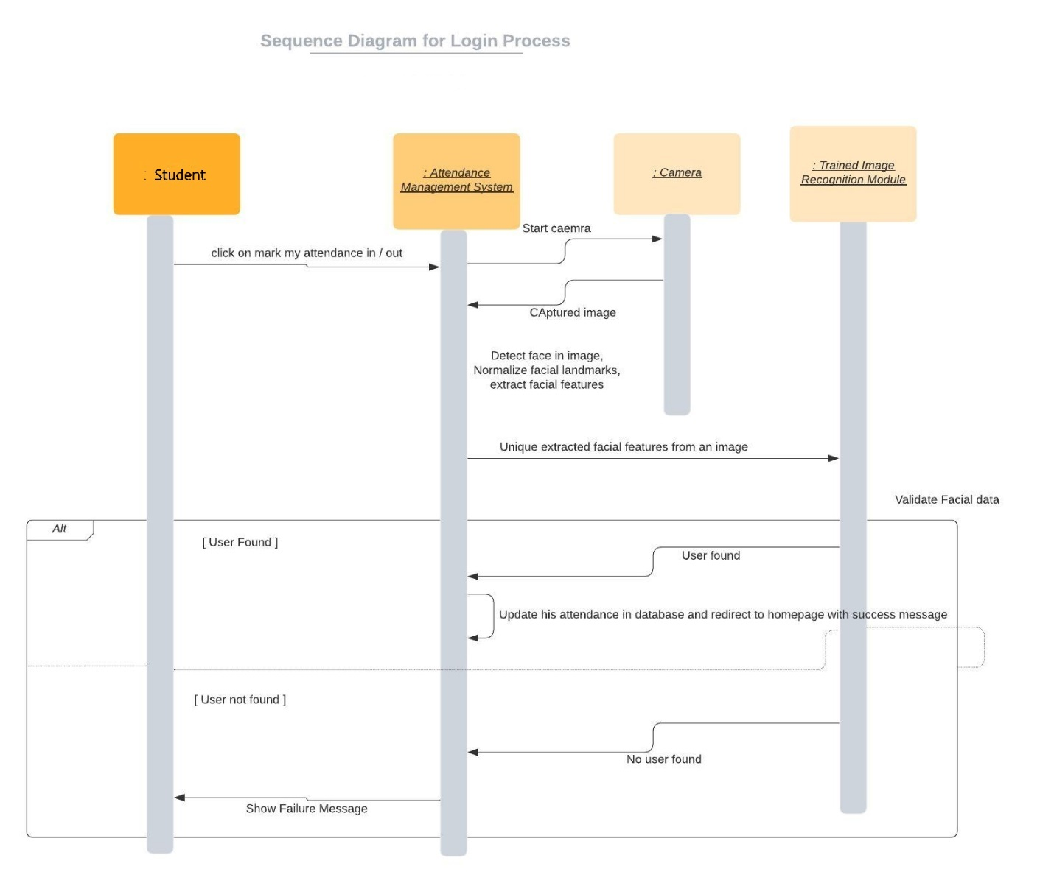

**4.4.3 USER PROCESS**

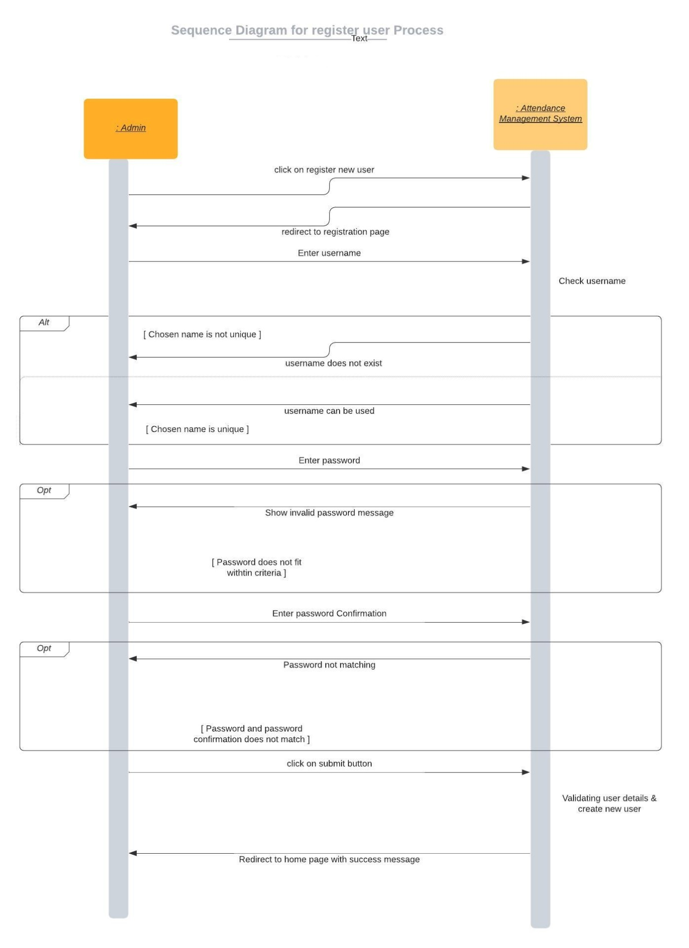

**4.5 ACTIVITY DIAGRAM**

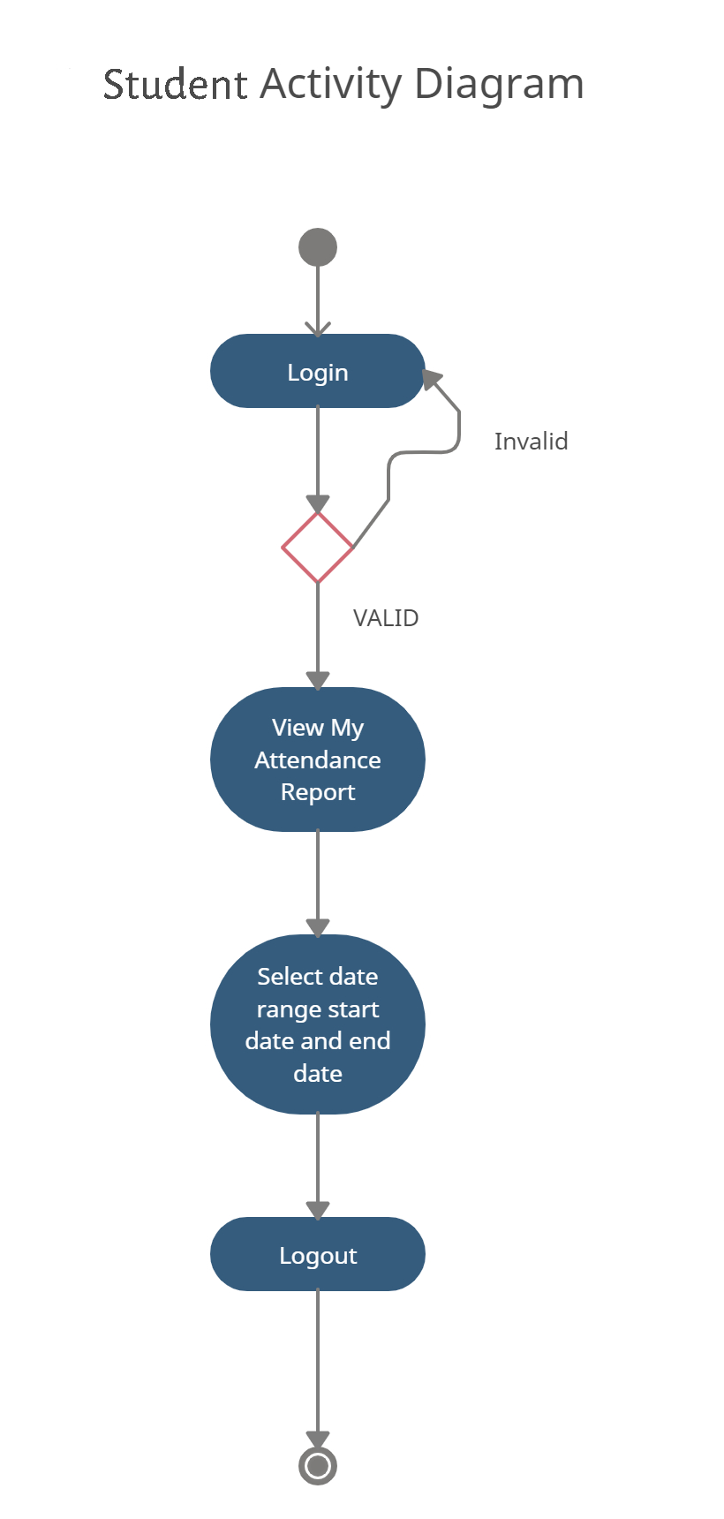**4.5.1 STUDENTS**

**4.5.2 ADMIN**

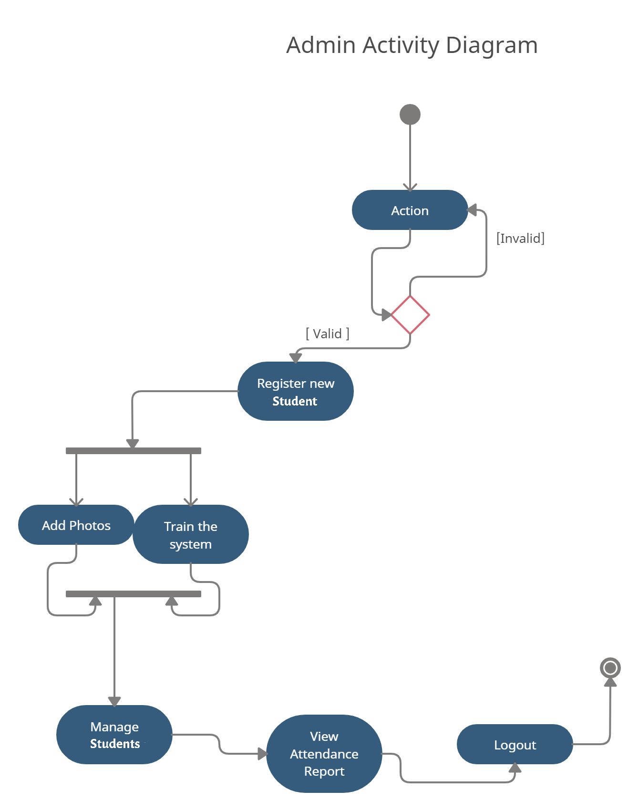

**4.5.3 ATTENDANCE TRACKING**

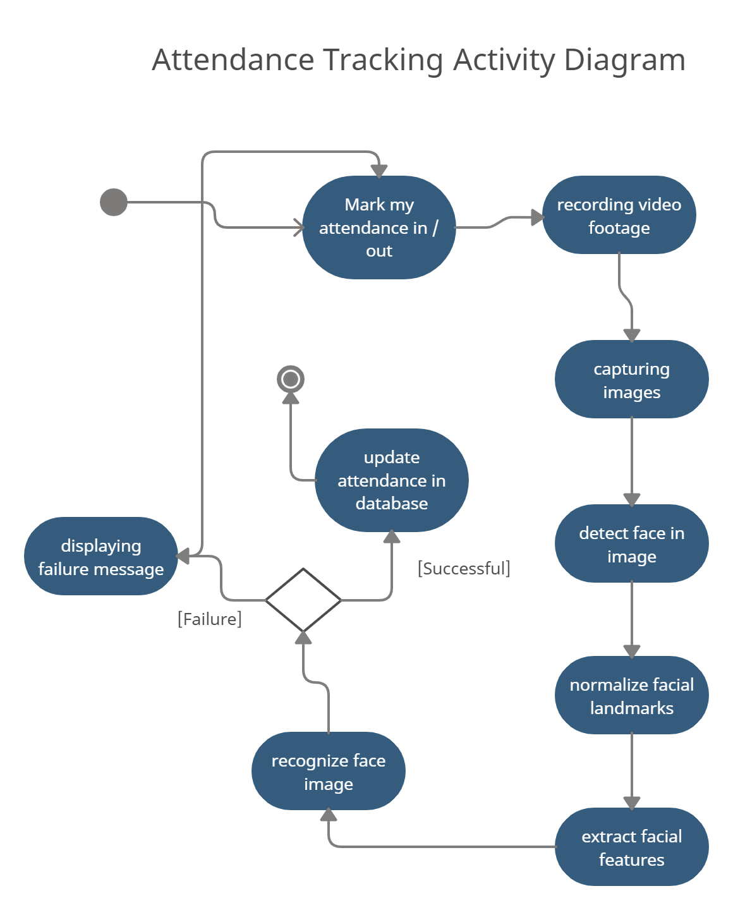

**4.6 E-R DIAGRAM**

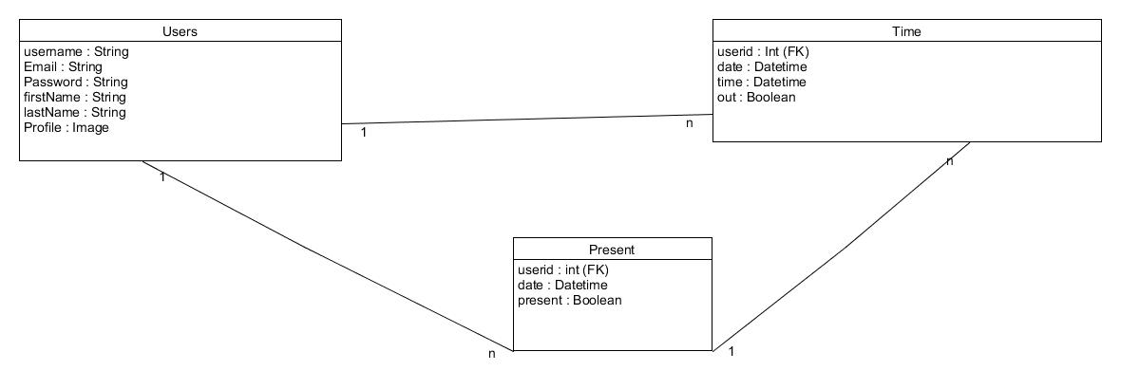

We have prepare ER-Diagram for displaying relation between entity such as users, their attendance time-in and time-out, the status of presence.

**4.7 COMPONENT DIAGRAM**

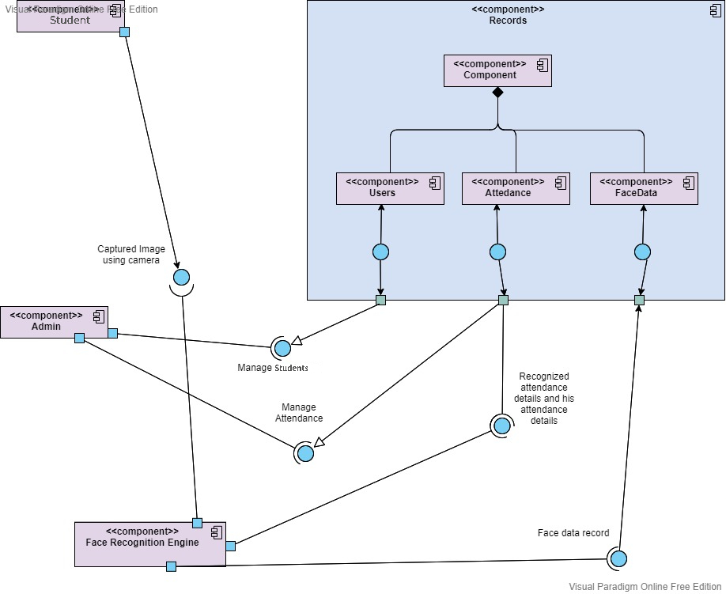

We prepare component diagram to describe the organization and wiring of the physical components in a system. Component diagram are often drawn to help model implementation details and double-check that every aspects of the system’s required functions.

**4.8 PACKAGE DIAGRAM**

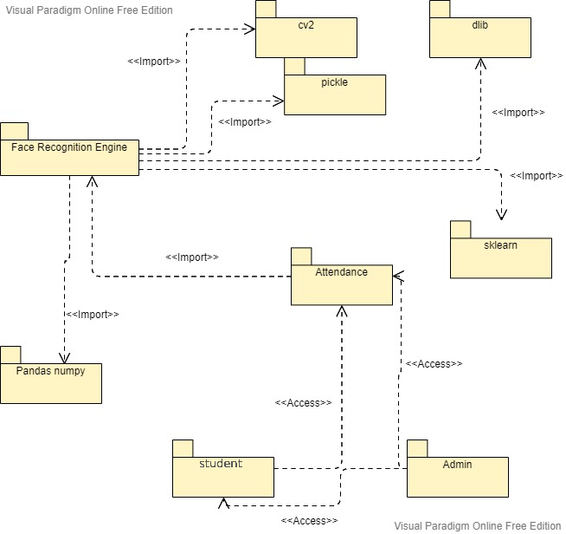

We prepare Package diagram to show the organization and arrangement of various model element in the form of Package. Package is a grouping of related UML elements such as diagrams, documents, classes or even other packages.

**4.9 DEPLOYMENT DIAGRAM**

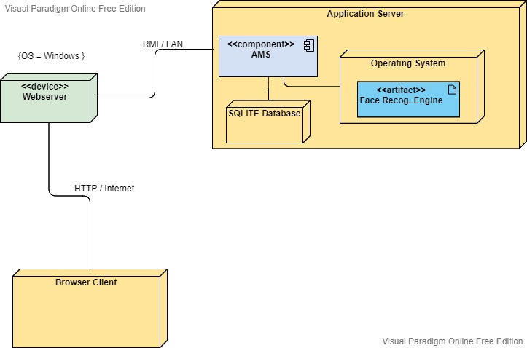

Deployment diagrams are UML diagram type that shows the execution architecture of the system, including nodes such as hardware or software execution environment, and the middleware connecting them. Deployment diagrams are typically used to visualize the physical hardware and software of a system

**Data Dictionary**

### User

|  |  |  |  |  |  |  |
| --- | --- | --- | --- | --- | --- | --- |
| **No** | **Field name** | **Data type** | **Required** | **Unique** | **PK / FK** | **Ref. Table** |
| 1 | UserId | int | true | true | PK | - |
| 2 | Email | string | true | true | - | - |
| 3 | Name | string | true | false |  | - |
| 4 | Password | string | true | false | - | - |
| 5 | CreatedAt | Datetime | true | false | - | - |
| 6 | UpdatedAt | Datetime | True | False | - | - |

### 

### Present

|  |  |  |  |  |  |  |
| --- | --- | --- | --- | --- | --- | --- |
| **No** | **Field name** | **Data type** | **Required** | **Unique** | **PK / FK** | **Ref. Table** |
| 1 | PId | int | true | true | PK | - |
| 2 | Date | Datetime | True | False | - | - |
| 3 | User | User | True | False | FK | Users |
| 4 | Present | Boolean | True | False | - | - |

### 

### Time

|  |  |  |  |  |  |  |
| --- | --- | --- | --- | --- | --- | --- |
| **No** | **Field name** | **Data type** | **Required** | **Unique** | **PK / FK** | **Ref. Table** |
| 1 | TId | int | true | true | PK | - |
| 2 | Date | Datetime | true | True | - | - |
| 3 | User | Users | True | False | FK | Users |
| 4 | Time | Datetime | False | False | - | - |
| 5 | Out | Boolean | True | False | - | - |

## Chapter 5

## Report on the Present Investigation

## 5.1 Methodology

## 

## 

## 

## This is our Automated face detection & recognization web based monitoring system, which we are going to apply for attendance management of our college library.

## We considered this application of our project as though we are having CCTV cameras installed at entrance as well as inside reading room/hall, we have to physically mark our presence & enter the details in the register.

## So this is our main dashboard where we are having mark-in & mark-out attendance buttons which we have to click for used for marking attendance. But they are only for Prototype pupose and this functions will be done automatically & continuously by CCTV cameras installed. After clicking of that button a camera window will starts & will defect the faces also will recognize them & will stated the details in the database Same for mark-out attendance 3rd option is Login where there are two types of Login users: Admin & student.Now Admin have to login the system for further features. After successfully login admin dashboard will open with features like registering new students , Training the New students , Adding their Photos, Training the system and Viewing Attendance Reports.This process will be similar as providing library cards to students by admin.After clicking register new student a form will open for registration. Here we are giving an only option for username and password because it will avoid unnecessary updation of student details frequently. We have also validated Username & password .After successfully register username admin have to add photos of students. Now After successful completing the process of adding photos of all students admin have to train from the system by clicking on train After successfully training a graph will be displayed of classification Now for attendance report have to click on it & an attendance dashboard well be open It will display today's statistics i.e no of students & todays present student. Also it displays Line graph of attendance of Last week & current week. We are also having function to sort and search details of students bey username & date also only by date of all students.After entering sorting details it displays, details like date, student username, present absent, Time in Time out, Hours spent, Break Hours, & bar graph for hours spent in library for each student.

## Also we have given option for student to track there records login in system and view their attendence records.

## 5.3 Implementation

## 5.3.1 Modules

The features of the system are mainly divided into 3 modules.

**5.3.1.1 Registration and Login Module**

This module mainly deals with the functionalities related to the registration of any new student to the organization, Log into the system and managing student’s profile details. Using features provided by this module admin can register new student to the system and admin / student both can log into the system using their credentials.

**5.3.1.2 Manage Attendance Details**

This module mainly deals with the features related to the student’s attendance. Using this student can mark their presence, time-in and time-out in the system. Admin can see the availability report of each student, student can see his/her attendance report along with some possible filters such as filter by student and filter by date.

**5.3.1.3 Manage Student Details**

This module mainly deals with the features related to the student’s profile. Using this admin can add a photo of the newly registered student during registration. Admin can also command the system explicitly to train the model and system will make necessary calculation and will generate some data which will be used internally to identify each student uniquely.

## 5.3.2 Function prototypes which implement major functionality

* List<Attendance> viewMyAttendanceReport(int empId);
* Int totalStudentsRegistered();
* List<Attendance> getAttendanceRecordByStudent(int empid);
* Boolean updateAttendanceRecord(int empid, Attendance update);
* Boolean registerStudent(Student new_student);
* Boolean addPhoto( int empId, string photo);

# **5.3.3 Testing**

Unit testing of each module was done after successfully completing the module. Each module was tested individually before integrating them with the whole system.

After integrating each module with the system, integration testing was done in order to check if modules are working properly together.

After completing all integrations, black-box testing of the whole system was carried out to ensure the system works in a correct manner.

**Black box testing of Major functions of the system**

### Log in to the system.

**Case 1:** Invalid Username or password entered by the user.

**Output:** Error message on the screen saying “Invalid credentials”

**Case 2:** Valid credentials.

**Output:** The user is redirected to the Dashboard page.

### Update Profile

**Case 1:** username already exists.

**Output:** Error message on the screen saying “Username already exists”

**Case 2:** Some of required fields missing in input.

**Output:** Model validation errors will be displayed to the user.

**Case 3:** All input data are valid.

**Output:** Profile updated successfully.

### View Attendance.

**Case 1:** User is not logged in.

**Output:** Redirected to the login page with error message “Please login!”.

**Case 2:** If a user exists and has the attendance records.

**Output:** All the chat history will be displayed

**Case 4:** Provided username does not exists in the system.

**Output:** 404 Error.

## Chapter 6 Results and Discussions

## 6.1.Main Dashboard (Time-in , Time-out and Login)

## 

## 6.2. Marking attendance in the system :

## 

## 6.3. Marking attendance out the system:

## 

## 6.4.Result of above attendance:

## 

## 6.5.User Login (Admin & Students):

## 

## 6.6.Admin Dashboard :

## 

## 6.7.Admin Features :

## 6.7.1.Student Registration ( Using Username & Password):

## 

## 6.7.2. Successful Registration:

## 

## 6.7.3.Adding images for student using username:

## 

## 6.7.4.Capturing images using web cam :

## 

## 6.7.5. Successful creation of dataset for training:

## 

## 6.7.6.Initialization of training dataset :

## 

## 6.7.7.Completion of Training dataset :

## 

## 6.6.8.Classification graph of trained dataset:

## 

## 6.8.Attendance Report :

## 

## 6.9.Searching of Records using username and from – to date :

## 

## 

## 6.10.Searching of record using particular date:

## 

## 

## 6.11.Student Dashboard :

## 

## 6.12.Student Features (Viewing attendance Report) :

## 

## Chapter 7

## Conclusion

**7.1 Functionalities implemented successfully:**

* Registration
* Login / Logout
* Manage User Profile
* Update user profile
* View My Attendance
* View Attendance by Date
* View Attendance by Student
* Manage Attendance
* Mark my attendance In
* Mark my attendance Out
* Add photos
* Add new student
* Train the system
* View Attendance record by date
* View no. of student present today
* View Total number of students

## 7.2 Limitations

* Attendance can be marked if the picture of an student is shown
* 300 images of each student are taken for better accuracy. 300 Images per student in a larger organization would consume a massive volume to store the images.
* The training time for our classifier takes about 20 seconds for each person. Hence for a large number of students, it would take a very long time to train. Though training the classifier isn’t something that needs to be frequently done, but it would be better if a classifier taking lesser time while maintaining the accuracy can be built.
* The current model is 99.38% Accurate

## 7.3 Functionalities not implemented

* Alert System
* Forgot Password
* Email Notifications

## 7.4 Possible future extensions

* A feature which can give intruder alert can be included in the system. Furthermore, the images of unknown people can be saved in an efficient manner and displayed in the system for better security.
* The number of training images can be reduced so that less storage is required. This can be done by removing duplicate images of the same person, or images with similar embeddings.
* The training time can be reduced by retraining the classifier only for the newly added images.
* A feature can be added where a student is automatically sent a warning if his attendance or working hours are below the threshold.
* Wrongly classified images can be added to the training dataset with the correct label so as to increase the accuracy of the recognition model.

## References

1. Student Attendance System using Face Recognition by Samridhi Dev ,Tushar Patnaik (Proceedings of the International Conference on Smart Electronics and Communication (ICOSEC 2020) IEEE Xplore Part Number: CFP20V90-ART; ISBN: 978-1-7281-5461-9)

**https://ieeexplore.ieee.org/document/9215441**

1. Face Detection and Recognition System using Digital Image Processing by Gurlove Singh, Amit Kumar Goel (Proceedings of the Second International Conference on Innovative Mechanisms for Industry Applications (ICIMIA 2020) IEEE Xplore Part Number: CFP20K58-ART; ISBN: 978-1-7281-4167-1)

**https://ieeexplore.ieee.org/document/9074838**

1. Face Recognition from Video using Deep Learning by Saibal Manna, Sushil Ghildiyal, Kishankumar Bhimani (Proceedings of the Fifth International Conference on Communication and Electronics Systems (ICCES 2020) IEEE Conference Record # 48766; IEEE Xplore ISBN: 978-1-7281-5371-1)

**https://ieeexplore.ieee.org/abstract/document/9138372**

1. Face Recognition Attendance System Based on Real-Time Video Processing by HAO YANG AND XIAOFENG HAN (SPECIAL SECTION ON GIGAPIXEL PANORAMIC VIDEO WITH VIRTUAL REALITY Received May 18, 2020, accepted June 25, 2020, date of publication July 10, 2020, date of current version September 11, 2020. Digital Object Identifier 10.1109/ACCESS.2020.3007205)

**https://ieeexplore.ieee.org/document/9137927**

## Appendix Technologies used

* **Django**

Django is a Python-based free and open-source web framework that follows the model–template–views (MTV) architectural pattern.It is maintained by the Django Software Foundation (DSF), an independent organization established in the US as a 501 non-profit. Django’s primary goal is to ease the creation of complex, database-driven websites. The framework emphasizes reusability and "pluggability" of components, less code, low coupling, rapid development, and the principle of don't repeat yourself. Python is used throughout, even for settings, files, and data models. Django also provides an optional administrative create, read, update and delete interface that is generated dynamically through introspection and configured via admin models. Some well-known sites that use Django include Instagram, Mozilla , ,Disqus , Bitbucket , Nextdoor and Clubhouse.

The MVT (Model View Template) is a software design pattern. It is a collection of three important components Model View and Template. The Model helps to handle database. It is a data access layer which handles the data. The Template is a presentation layer which handles User Interface part completely. The View is used to execute the business logic and interact with a model to carry data and renders a template. Although Django follows MVC pattern but maintains it’s own conventions. So, control is handled by the framework itself. There is no separate controller and complete application is based on Model View and Template. That’s why it is called MVT application.

* **Python**

Python is an interpreted, object-oriented, high-level programming language with dynamic semantics. Its high-level built in data structures, combined with dynamic typing and dynamic binding, make it very attractive for Rapid Application Development, as well as for use as a scripting or glue language to connect existing components together. Python's simple, easy to learn syntax emphasizes readability and therefore reduces the cost of program maintenance. Python supports modules and packages, which encourages program modularity and code reuse. The Python interpreter and the extensive standard library are available in source or binary form without charge for all major platforms, and can be freely distributed.

* **Sqlite**

SQLite is an in-process library that implements a self-contained, serverless, zero-configuration, transactional SQL database engine. It is a database, which is zero-configured, which means like other databases you do not need to configure it in your system.SQLite engine is not a standalone process like other databases, you can link it statically or dynamically as per your requirement with your application. SQLite accesses its storage files directly.SQLite does not require a separate server process or system to operate (serverless).SQLite comes with zero-configuration, which means no setup or administration needed.A complete SQLite database is stored in a single cross-platform disk file.SQLite is very small and light weight, less than 400KiB fully configured or less than 250KiB with optional features omitted.SQLite is self-contained, which means no external dependencies.SQLite transactions are fully ACID-compliant, allowing safe access from multiple processes or threads.SQLite supports most of the query language features found in SQL92 (SQL2) standard.SQLite is written in ANSI-C and provides simple and easy-to-use API.SQLite is available on UNIX (Linux, Mac OS-X, Android, iOS) and Windows (Win32, WinCE, WinRT).

* **IMAGE ACQUISITION**

**OpenCV (*Open-Source Computer Vision Library*)**

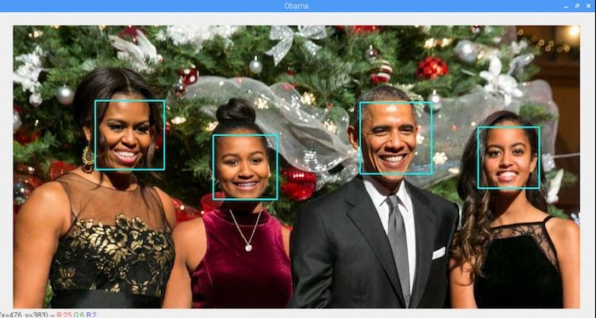

* It is used for image and video analysis, like facial detection, license plate reading, photo editing, advanced robotic vision, optical character recognition, and a whole lot more
* It helps us to develop a system which can process images and real-time video using computer vision

**GAN** *(****Generative Adversarial Networks****)*

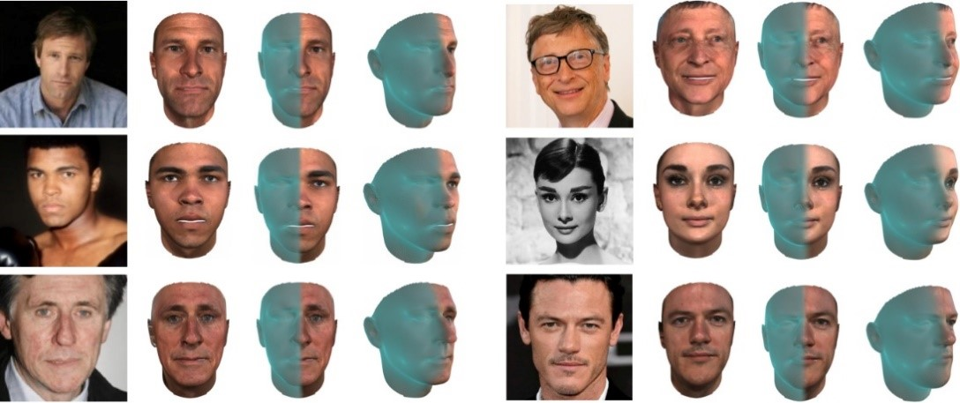

* It incorporate a 3D morphable model into the generator of a GAN.
* It allows generation of new, synthetic identities, and manipulation of pose, illumination and expression without compromising the identity

**YOLO**(***You Only Look Once***)

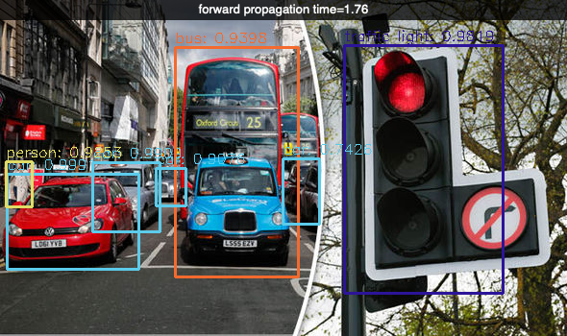

* It Convolutional Neural Networks that achieve near  
   state-of-the-art results with a single end-to-end model   
  that can perform object detection in real-time
* YOLO is agile and efficient in detecting and classifying the objects.
* YOLO outperforms them in real time object detection  
   at a speed of 45 frames per second
* Haar cascade classifier’s shortcomings have been   
  overcome by YOLO
* **PREPROCESSING**

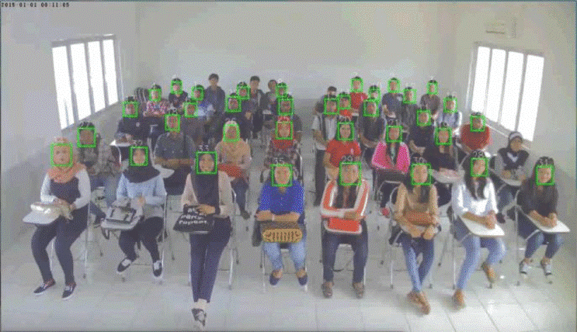 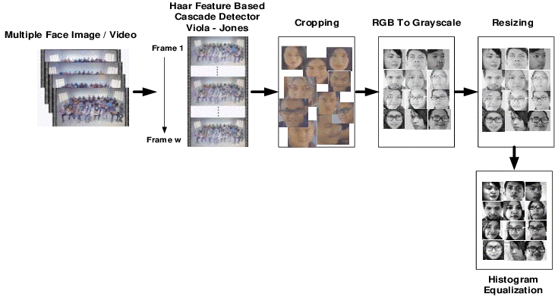

* The image is transformed from RGB to Grayscale because it is easy to detect faces in the grayscale
* In image manipulation, resizing, cropping, blurring and sharpening of the images is done.
* The image segmentation, which is used for contour detection or segments the multiple objects in a single image so that the classifier can quickly detect the objects and faces in the picture

* **FEATURE EXTRACTION**

**GABOR FILTERS**

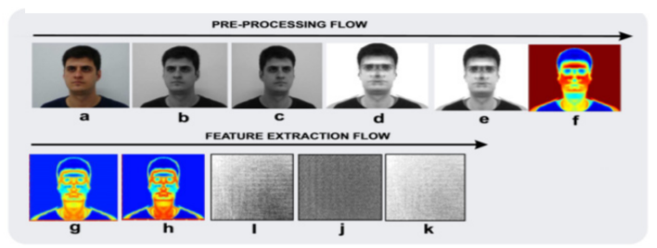

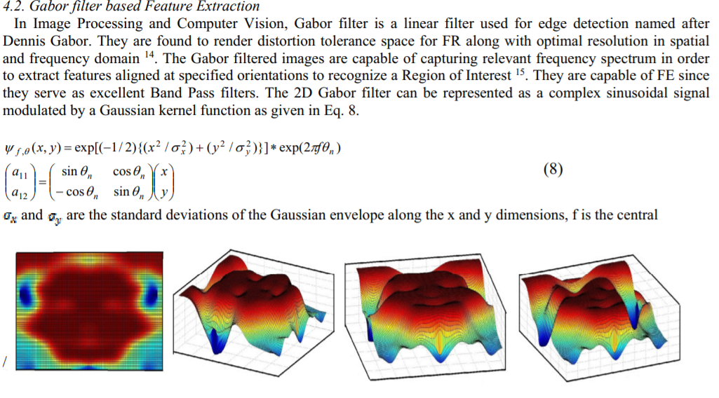

* It is a type of linear filter.
* It is a special class of bandpass filters, i.e. they allow a specific range of frequencies and reject others.
* When a Gabor filter is applied to an image, it gives the highest response at edges and at points where texture changes.
* A Gabor filter is essentially a sinusoidal signal with a given frequency and orientation, modulated by a Gaussian equation.

* **CLASSIFICATION MODEL**

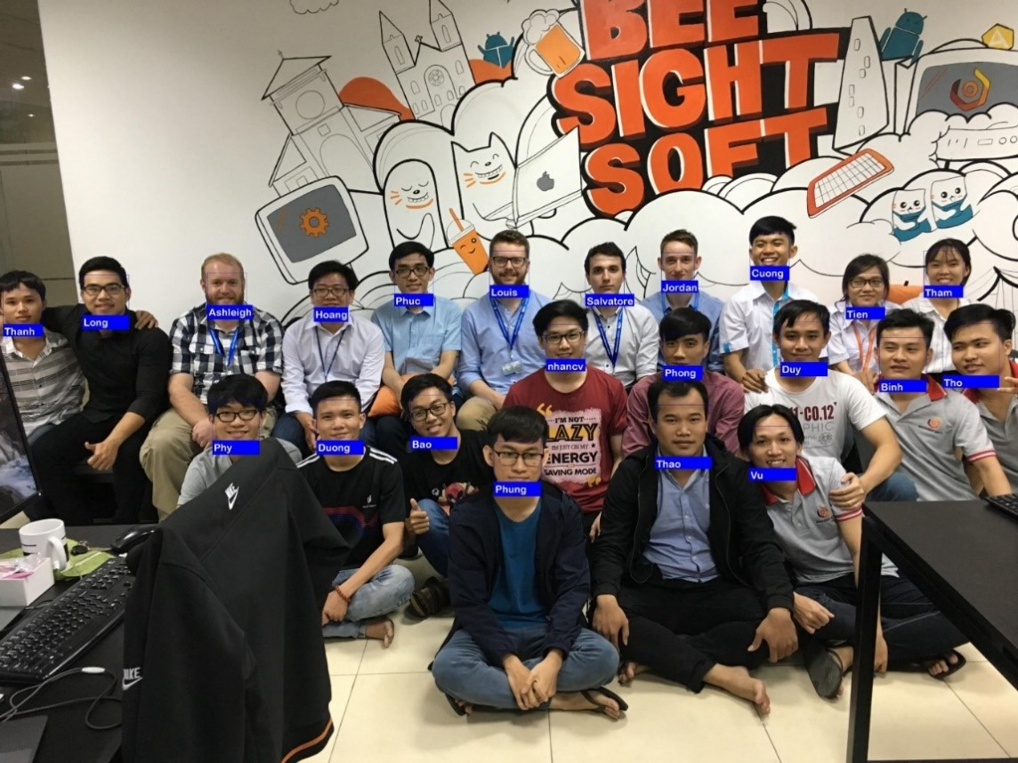

* KNN is used which gives accuracy, robustness and less time complexity
* KNN is non-parametric
* KNN is termed memory-based or lazy learning
* In KNN an object is classified based on the majority votes of its neighbors ie. the training set. The new example object are going to be assigned to the category with its most similar k nearest neighbors

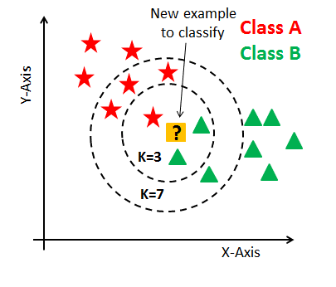

**PAPER PUBLICATION**

